Global Journal of Engineering Science and Researches
DESIGN AND ANALYSIS OF A GO-KART BY CAD SOFTWARE
Anurag Rai ^{*1} & Priyatam Kumar Srivastava²
^{*1&2}Department of Mechanical Engineering, Ambalika Institute of Management and Technology, Lucknow

ABSTRACT
This report documents the process and methodology to produce a low cost go-kart which is comfortable, vulnerable, durable and complete in all aspects by modeling it with CAD software The feasibility of the go-kart design was examined through FMEA, Cost report. The team focuses on a technically sound vehicle which is backed by a profound design and good manufacturing practices. The report explains approach, reasons, selecting criteria and expected working of the vehicle parameters. The procedural way of explanation is used for different parts of the vehicle, which starts from approach with the help of known facts, then the design and calculation procedure has been explained. The best way known had been use to go on to the final result of all parameters.

Keywords: CAD Software, Cost Report, Design, FEMA.

- INTRODUCTION

The go-kart will be built from the ground up to maximize the efficient use of space, and to ensure that the needs of the client are met. We approached our design by considering all possible alternatives for a system & modeling them in CAD software like CREO Parametric 2.0 and subjected to analysis using AUTOCAD software. Based on analysis result, the model was modified and retested and a final design was frozen. The design process of the vehicle is iterative and is based on various engineering and reverse engineering processes depending upon the availability, cost and other such factors. So the design process focuses on following objectives: Safety, Serviceability, Strength, ruggedness, Standardization, Cost, Driving feel and ergonomics, Aesthetics. The design objectives set out to be achieved were three simple goals applied to every component of the car: durable, light-weight, and high performance, to optimizing the design by avoiding over designing, which would also help in reducing the cost. With this we had a view of our kart.

This started our goal and we set up some parameters for our work, distributed ourselves in groups for the technical design of our vehicle. Sub-Departments for Design:-
- Chassis Department.
- Steering Department
- Brakes and Tyres Department
- Transmission Department

DISPLACEMENT | 135 cc
Max power | 13 bhp @ 9000rpm
Max torque | 11 Nm @ 7500rpm
Bore | 54 mm
Stroke | 59 mm
Valves per cylinder | 4
Gearbox type | Manual
Transmission type | Shaft drive
Fuel type | Petrol
Clutch | Wet Multiplate
Fuel delivery system | carburetor
Spark plugs | 2 per cylinder
No. of gears | 5
Cooling system | Air cooled

- MATERIAL USED FOR CHASSIS (MILD STEEL)

Mild Steel is believed to be the best metallic material for the cylindrical piping chassis of the go-kart. Mild steel contains 92% of iron content, 0.2 % carbon content and 7.8% is alloyed of Silicon, Manganese, Phosphorus, Copper, Cobalt Chromium Mild steel (AGrade) is light weight when compared to Galvanized Iron and also the Ultimate tensile and compressive strength is high. Also the mild steel is ductile unlike Galvanized iron which is Brittle.

In college we have performed test on real time samples of Mild steel of diameter and thickness and we have got the following results.
1:Rockwell hardness no.
2:Brinell hardness no.
3:Maximum compression load.

The current market analysis cost of mild steel is 120 per Kg in Indian Market and in a standard Go-Kart Chassis nearly 15 Kg of bulk material including the wastage done in the fabrication of chassis is used. If taken assumptions, the approximate length of pipe required is 20 feet.

Also, Mild steel has various advantages over other materials which are
Ductile
Weldable
recyclable
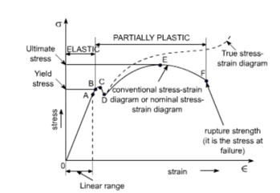

- MATERIAL AVAILABILITY

Tubing is available in standard fractional sizes to the 1/8th of an inch: 1, 1.12, 1.25 and 1.5. The wall thickness is limited to the common Birmingham Tubing Gauges. In this case these are: 1.5, 1.8, 2, 2.5 and 3 mm. It is observed that material which has high machinability and inexpensive is AISI 1018, hence was a good choice but strength to weight ratio is greater for 4130. AISI 1020 was rejected because of its high cost. AISI 4130 was rejected because of its high carbon content and lack of machinability, 4130. have the superior harden ability that other iron alloys like 4130 and 4140 possess. But 4130 is a popular steel in race car industry but is not easily available in India.

Therefore, the material that the team chose to use is AISI 1018. The benefit of using the AISI 1018 is that it can be easily wielded than the 4130 chromyl. The AISI 1018 has the same Modulus of Elasticity (E) and density as the 4130, so using it does not affect the weight or stiffness in member with same geometry.

AISI 1018 has some features which are suitable for making of the GO-KART, it posseses good strength over the other steels and strength is one of the major criteria for selection of the material for the GO-KART.

Stress strain diagram of a mild steel sample

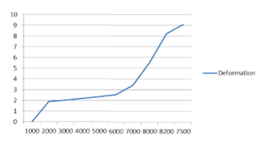
The above Graph Shows total structural deformation versus the load applied to a sample of mild steel hollow pipe.

- MATERIALS USED FOR AXLE (HARDENED STEEL)

The Material used for the Axle should have a comparatively high torsional value so that when the axle is rotating at high speed it should not bend because of the torsional forces applied to it. Plus, it should also have high tensile and compressive strength.

- FINAL DESIGN MODEL

The Solid-works model of our GO-KART is and shown below and briefings are also discussed along with them i.e. the reason for designing it in such way.

1. Chassis
The chassis has been designed by taking factors like dimensional limits (width, height, length, and weight), operational restrictions, regulatory issues, contractual requirements, financial constraints and human ergonomics as a priority. A basic chassis frame of circular pipes of 1.25 inch diameter and 2mm thickness was designed and selected by taking the points of strength, availability and cost into consideration.
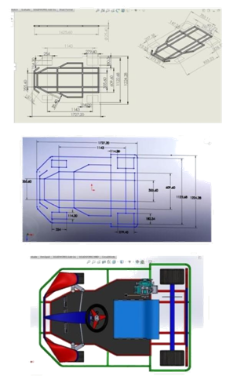
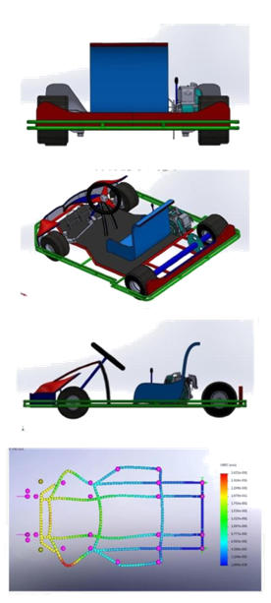
Steering
The control of an automobile is done by means of a steering system which provides directional changes to the moving automobile.

Ackermann principal of steering
To solve the problem of wheels on the inside and outside of a turn needing to trace out circles of different radius, Ackermann principle of steering is used.

Assumptions
- 100% Ackermann steering geometry.
- Maximum road bank angle is 20°.

- Optimum kingpin inclination angle range is 4° to 8°.
- Front to rear weight ratio is 42:58.
- Taking acceleration due to gravity as 10m/s².

Calculations
- Vertical force (on one tyre)
= 388.5 .
- Lateral force (on one tyre)
= × (Ø) = 132.87

Where, Ø – maximum road bank angle
- Total Aligning Torque ( Mz ) is
= + √ ( ² + ²)

Where,

Ma = aligning torque on left tyre, Mb = aligning torque on right tyre,

- = Kingpin angle, ʋ = Caster angle.

Mechanical trail (m) = ground trail × sin (castor angle)

m = 48.75 mm

(Mechanical trail is calculated using geometry with the help of castor angle)
= × = 6477.4

Aligning torque on each tyre will be same so “Ma=Mb” and assuming the total aligning torque (Mz) to be 12000Nmm the castor angle ( ʋ ) and kingpin angle ( ƛ ) is thus calculated by hit and trial method in the equation above.

Kingpin angle ( ƛ ) = 6.9°
Castor angle ( ʋ ) = 21°
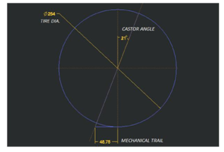

Analysis on the stub axle is done by applying a force of 410N in upward direction and FOS calculated is = 4.15.
Ackermann angle (ɑ)
ɑ = − 1 [ 0.5 × |  | ℎ | ]
 |  | ℎ
=22.17°

Inner angle (a)
^{= [} _{− {2 }} ]

a = 24.72º

Outer angle (b)
^{= [} _{+ {2 }} ]

b = 17.59°

Turning radius(R)
= |  |  | +
 |  |  |  | Ɣ

Where,
- (average steer angle) = ( + /2) W (track width) = 1123mm

H (wheel base) = 1143mm
R = 3043.16mm or 3.04m

The Centre to centre distances between the sleeve and steering arms are 89mm &127mm respectively. The angular distance covered by the steering arm is 78.23mm.corresponding to the inner steer angle of 24.72°. The same angular distance must be travelled by the sleeve and corresponding to the angular distance the sleeve should rotate by 50.52°, which is same the steering wheel has to be turned to rotate the inner wheel by 24.72°.

Steering ratio(r)

₌ ℎ ℎ

^{50.52}_{24.72} = 2.04
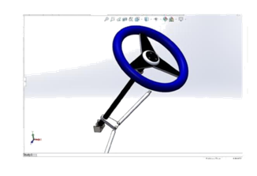
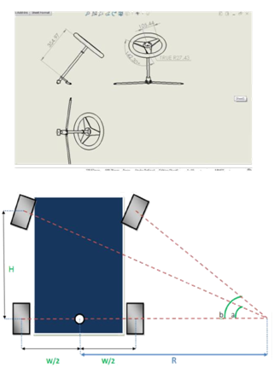

TRANSMISSION CALCULATIONS

REFERENCES
- Dev R. and Tiwari G.N. Characteristic equation of a passive solar still. Desalination 2009; 245:246–65.
- Tiwari G.N. and Tiwari A.K. Solar distillation practice for water desalination systems.New Delhi: Anamaya Publishers; 2008.
- Velmurugan V. and Srithar K. Solar stills integrated with amini solar pond—analytical simulation and experimental validation. Desalination 2007; 216:232–41.
- Dunkle R.V. Solar water distillation, the roof type solar still and a multi effect diffusion still, International developments in heat transfer, ASME Proceedings of International Heat Transfer, University of Colorado. 1961; 5:895–902.
- Tiwari G.N., Dimri Vimal, Singh Usha, Chel Aravind and Sarkar Bikash. Comparative thermal performance evaluation of an active solar distillation system. International Journal of Energy Research 2007; 31:1465–82.
- Omar O Badran and Mazen M Abu-Khader. Evaluating thermal performance of a single slope solar still. Heat Mass Transfer 2007; 43:985–95.
- Tiwari G.N. Solar energy: fundamentals, design, modelling and application. New Delhi: Narosa Publishing House; 2004. p. 278–306.
- Abdul Jabbar, N. Khalifa and Ahmad M. Hamood. Effect of insulation thickness on the productivity of basin type solar stills: An experimental verification under local climate. Energy Conversion and Management 50 (2009) 2457–2461.
- Tiwari G.N., Vimal Dimri and Arvind Chel, Parametric study of an active and passive solar distillation system: energy and exergy analysis. Desalination 2009; 242:1–18

